## Exercise 1.8.4: National Sports

In this exercise, you’ll be making a table to show information about different countries’ national sport.

**STARTER CODE**

The given web page shows a table with three rows. The first row contains the table headers that describe which information should be in each column. The second and third rows contain the information for an example country:

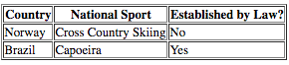

**YOUR JOB**

Add three more countries’ national sports. You can find a list of the national sports here: <https://en.wikipedia.org/wiki/National_sport>

Include all the information for each country in the table (country name, sport name, established by law).

The table should have at least 5 countries in total.

**BONUS CHALLENGE**

Add extra columns to the table to describe more information about each sport!

Each new column should have its own table header describing the information in that column.